Q19 Write PL/SQL code to display employee details using Explicit Cursors ?
CREATE TABLE EMPLOYEE2(empId int ,empName varchar(40),designation varchar(30));

INSERT INTO EMPLOYEE2 values (101,'xyz','ANDROID DEVLOPER');
INSERT INTO EMPLOYEE2 values (102,'wyz','Frontend DEVLOPER');
INSERT INTO EMPLOYEE2 values (103,'SHAM','DEVOPS DEVLOPER');
INSERT INTO EMPLOYEE2 values (104,'RAJ','ML DEVLOPER');
INSERT INTO EMPLOYEE2 values (105,'RAM','ANDROID DEVLOPER');

DECLARE
CURSOR emp IS SELECT empId ,empName,designation FROM EMPLOYEE2;
v_empid EMPLOYEE.empId%TYPE;
v_empName EMPLOYEE.empName%TYPE;
v_designation EMPLOYEE.designation%TYPE;

BEGIN
OPEN emp;
LOOP
FETCH emp INTO v_empid,v_empname,v_designation;
EXIT WHEN emp%NOTFOUND;
DBMS_OUTPUT.PUT_LINE(v_empid || ' ' || v_empname || ' ' || v_designation);
END LOOP;
CLOSE emp;

END;

OUTPUT:

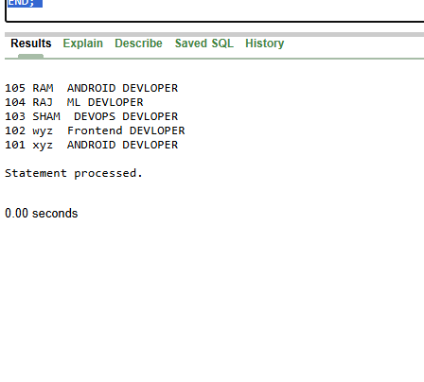

Q20. PL/SQL code to retrieve employee name, join date, and designation from employee database of an employee whose number is input by the user.

CREATE TABLE EMPLOYEE2(empId int ,empName varchar(40),designation varchar(30));

INSERT INTO EMPLOYEE2 values (101,'xyz','ANDROID DEVLOPER');
INSERT INTO EMPLOYEE2 values (102,'wyz','Frontend DEVLOPER');
INSERT INTO EMPLOYEE2 values (103,'SHAM','DEVOPS DEVLOPER');
INSERT INTO EMPLOYEE2 values (104,'RAJ','ML DEVLOPER');
INSERT INTO EMPLOYEE2 values (105,'RAM','ANDROID DEVLOPER');

DECLARE
v_empid EMPLOYEE2.empId%TYPE := 101;
v_empname EMPLOYEE2.empName%TYPE;
v_designation EMPLOYEE2.designation%TYPE;

BEGIN
SELECT empName, designation
INTO v_empname, v_designation
FROM EMPLOYEE2
WHERE empId = v_empid;

DBMS_OUTPUT.PUT_LINE('ID: ' || v_empid);
DBMS_OUTPUT.PUT_LINE('Name: ' || v_empname);
DBMS_OUTPUT.PUT_LINE('Designation: ' || v_designation);

EXCEPTION
WHEN NO_DATA_FOUND THEN
DBMS_OUTPUT.PUT_LINE('Employee not found');
WHEN TOO_MANY_ROWS THEN
DBMS_OUTPUT.PUT_LINE('More than one employee found');
END;

OUTPUT:

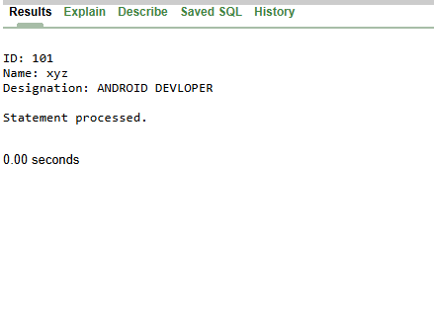

Q21. Write a PL/SQL code to update the salary of employees who earn less than the average salary using cursor.

BEGIN
UPDATE EMPLOYEE2
SET salary = salary + (salary * 0.10)
WHERE salary < (SELECT AVG(salary) FROM EMPLOYEE2);

COMMIT;
END;
/
SELECT * FROM EMPLOYEE2;

OUTPUT :
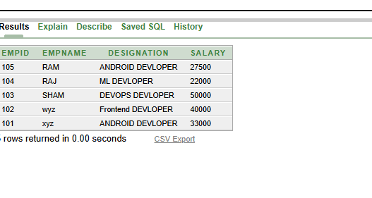

Q22 Write a row trigger to insert the existing values of the salary table into a new table when the salary table is updated.

CREATE TABLE SALARY_BACKUP (
empId NUMBER,
old_salary NUMBER,
updated_on DATE
);

CREATE OR REPLACE TRIGGER trg_salary_update
BEFORE UPDATE ON EMPLOYEE2
FOR EACH ROW
BEGIN
INSERT INTO SALARY_BACKUP
VALUES (:OLD.empId, :OLD.salary, SYSDATE);
END;
/

UPDATE EMPLOYEE2
SET salary = salary + 1000
WHERE empId = 101;

COMMIT;
SELECT * FROM SALARY_BACKUP;

OUTPUT:

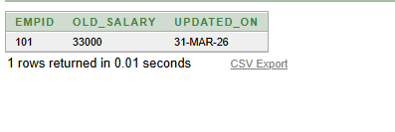

Q23. Write a PL/SQL procedure to find the number of students ranging from 100–70%, 69–60%, 59–50% & below 49% in each course from the STUDENT_COURSE table. The counts should be passed as parameters.

CREATE TABLE STUDENT_COURSE (
id NUMBER,
percentage NUMBER
);

INSERT INTO STUDENT_COURSE VALUES (1, 85);
INSERT INTO STUDENT_COURSE VALUES (2, 72);
INSERT INTO STUDENT_COURSE VALUES (3, 65);
INSERT INTO STUDENT_COURSE VALUES (4, 55);
INSERT INTO STUDENT_COURSE VALUES (5, 45);
INSERT INTO STUDENT_COURSE VALUES (6, 30);

CREATE OR REPLACE PROCEDURE student_count_proc(
a OUT NUMBER,
b OUT NUMBER,
c OUT NUMBER,
d OUT NUMBER
)
AS
BEGIN
SELECT COUNT(*) INTO a FROM STUDENT_COURSE WHERE percentage >= 70;
SELECT COUNT(*) INTO b FROM STUDENT_COURSE WHERE percentage >= 60 AND percentage < 70;
SELECT COUNT(*) INTO c FROM STUDENT_COURSE WHERE percentage >= 50 AND percentage < 60;
SELECT COUNT(*) INTO d FROM STUDENT_COURSE WHERE percentage < 50;
END;
/

DECLARE
x NUMBER;
y NUMBER;
z NUMBER;
w NUMBER;
BEGIN
student_count_proc(x, y, z, w);

DBMS_OUTPUT.PUT_LINE('70-100: ' || x);
DBMS_OUTPUT.PUT_LINE('60-69: ' || y);
DBMS_OUTPUT.PUT_LINE('50-59: ' || z);
DBMS_OUTPUT.PUT_LINE('Below 50: ' || w);
END;
/

OUTPUT:
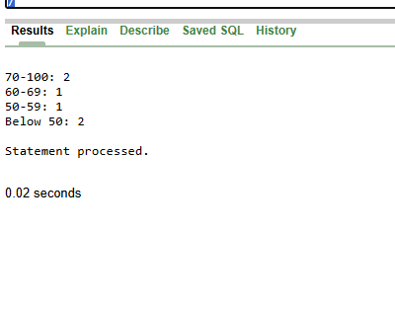

Q24Create a store function that accepts 2 numbers and returns the addition of passed values. Also, write the code to call your function.

CREATE OR REPLACE FUNCTION add_two_numbers(a NUMBER, b NUMBER)
RETURN NUMBER
IS
BEGIN
RETURN a + b;
END;
/
DECLARE
result NUMBER;
BEGIN
result := add_two_numbers(10, 20);
DBMS_OUTPUT.PUT_LINE('Sum = ' || result);
END;
/

OUTPUT:
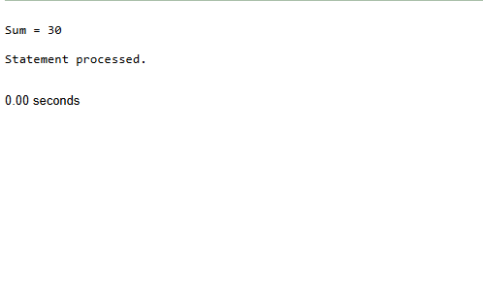

Q25. Write a PL/SQL function that accepts the department number and returns the total salary of the department. Also write a function call.

-- Create new table
CREATE TABLE EMP_DEPT (
empId NUMBER,
empName VARCHAR2(40),
salary NUMBER,
department_id NUMBER
);

-- Insert sample data
INSERT INTO EMP_DEPT VALUES (101, 'A', 30000, 1);
INSERT INTO EMP_DEPT VALUES (102, 'B', 40000, 1);
INSERT INTO EMP_DEPT VALUES (103, 'C', 50000, 2);
INSERT INTO EMP_DEPT VALUES (104, 'D', 20000, 2);
INSERT INTO EMP_DEPT VALUES (105, 'E', 25000, 3);

CREATE OR REPLACE FUNCTION total_salary(dept_id NUMBER)
RETURN NUMBER
IS
total NUMBER;
BEGIN
SELECT SUM(salary) INTO total
FROM EMP_DEPT
WHERE department_id = dept_id;

RETURN total;
END;
/

SELECT total_salary(1) FROM dual;

OUTPUT:
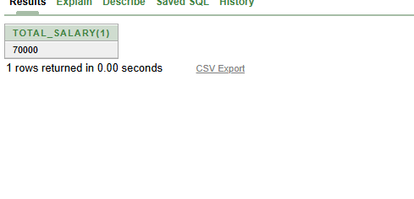

Q26Write a program to illustrate user-defined exceptions, built-in exceptions, and raise application error exceptions.

DECLARE
my_exception EXCEPTION;
num NUMBER := 0;
result NUMBER;
BEGIN
result := 10 / num;
IF num = 0 THEN
RAISE my_exception;
END IF;
EXCEPTION
WHEN ZERO_DIVIDE THEN
DBMS_OUTPUT.PUT_LINE('Built-in Exception: Divide by zero');
WHEN my_exception THEN
DBMS_OUTPUT.PUT_LINE('User-defined Exception occurred');
WHEN OTHERS THEN
RAISE_APPLICATION_ERROR(-20001, 'Application Error occurred');
END;
/

OUTPUT:

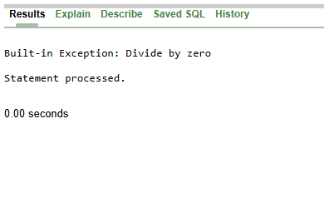

27 . Write a program to Reverse a String Using PL/SQL Block.

DECLARE
str VARCHAR2(50) := 'HELLO';
rev VARCHAR2(50) := '';
i NUMBER;
BEGIN
FOR i IN REVERSE 1..LENGTH(str) LOOP
rev := rev || SUBSTR(str, i, 1);
END LOOP;
DBMS_OUTPUT.PUT_LINE('Original: ' || str);
DBMS_OUTPUT.PUT_LINE('Reversed: ' || rev);
END;
/

OUTPUT:
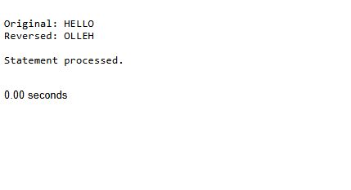

28. Create a trigger that records changes on an EMPLOYEES table (INSERT, UPDATE, DELETE) into an EMPLOYEES_AUDIT table. Include details like EMPLOYEE_ID, OPERATION_TYPE, TIMESTAMP.

CREATE TABLE EMPLOYEES (
employee_id NUMBER,
name VARCHAR2(50),
salary NUMBER
);

CREATE TABLE EMPLOYEES_AUDIT (
employee_id NUMBER,
operation_type VARCHAR2(10),
action_date DATE
);

CREATE OR REPLACE TRIGGER emp_audit_trigger
AFTER INSERT OR UPDATE OR DELETE ON EMPLOYEES
FOR EACH ROW
BEGIN
IF INSERTING THEN
INSERT INTO EMPLOYEES_AUDIT
VALUES (:NEW.employee_id, 'INSERT', SYSDATE);

ELSIF UPDATING THEN
INSERT INTO EMPLOYEES_AUDIT
VALUES (:NEW.employee_id, 'UPDATE', SYSDATE);

ELSIF DELETING THEN
INSERT INTO EMPLOYEES_AUDIT
VALUES (:OLD.employee_id, 'DELETE', SYSDATE);
END IF;
END;
/

INSERT INTO EMPLOYEES VALUES (1, 'A', 30000);

UPDATE EMPLOYEES SET salary = 35000 WHERE employee_id = 1;

DELETE FROM EMPLOYEES WHERE employee_id = 1;
SELECT * FROM EMPLOYEES_AUDIT;

OUTPUT:
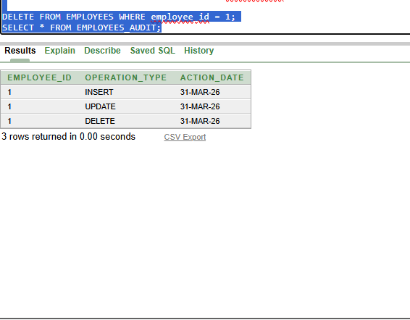

Q29 Write a PL/SQL block to demonstrate the use of aggregate functions (COUNT, SUM, AVG, MAX, MIN).

DECLARE
total NUMBER;
avg_sal NUMBER;
max_sal NUMBER;
min_sal NUMBER;
count_emp NUMBER;
BEGIN
SELECT
COUNT(*),
SUM(salary),
AVG(salary),
MAX(salary),
MIN(salary)
INTO
count_emp,
total,
avg_sal,
max_sal,
min_sal
FROM EMP_DEPT;

DBMS_OUTPUT.PUT_LINE('Count = ' || count_emp);
DBMS_OUTPUT.PUT_LINE('Sum = ' || total);
DBMS_OUTPUT.PUT_LINE('Average = ' || avg_sal);
DBMS_OUTPUT.PUT_LINE('Max = ' || max_sal);
DBMS_OUTPUT.PUT_LINE('Min = ' || min_sal);
END;
/

OUTPUT:
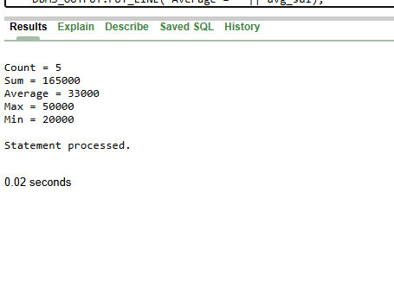

Q30. Write a PL/SQL program using a cursor to display employee details.

DECLARE
CURSOR emp_cursor IS
SELECT empId, empName, salary FROM EMP_DEPT;

v_id EMP_DEPT.empId%TYPE;
v_name EMP_DEPT.empName%TYPE;
v_salary EMP_DEPT.salary%TYPE;

BEGIN
OPEN emp_cursor;

LOOP
FETCH emp_cursor INTO v_id, v_name, v_salary;
EXIT WHEN emp_cursor%NOTFOUND;

DBMS_OUTPUT.PUT_LINE(v_id || ' ' || v_name || ' ' || v_salary);
END LOOP;

CLOSE emp_cursor;
END;
/

OUTPUT:
